**Project Title : Customer Care Registry Project Design Phase-I** - **Solution Fit Template Team ID:** PNT2022TMID52282

**Focus on J&P, tap into BE, understand RC**

**Explore AS, differentiate**

**Deﬁne CS, ﬁt into CC**

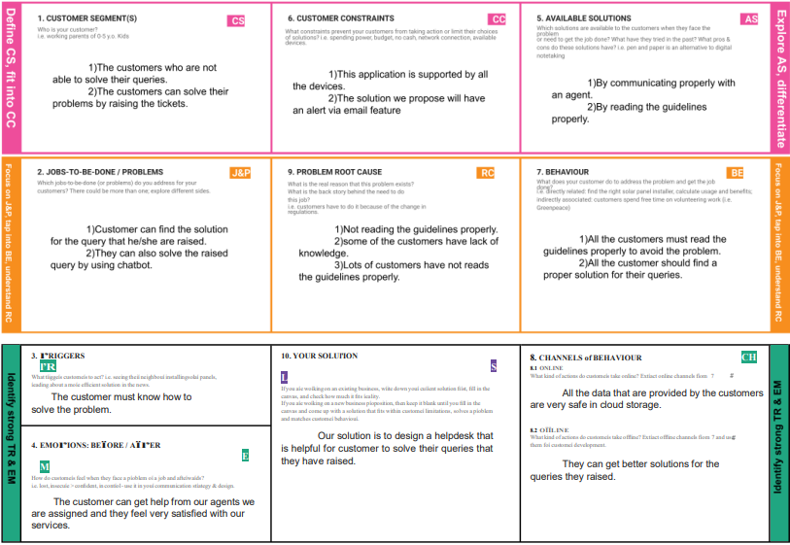

**Identify song TR & EM**